- LAN IP, DHCP, DNS, VLAN & NAT PRACTICAL ASSIGNMENT

Q1. Assign Static IP Addresses to Five Devices
Objective: Place five devices in the same subnet, configure static IPv4 addresses, and verify communication with ping.

Procedure
1. Create a small LAN using five PCs/laptops and a switch.
2. Connect every device to the switch using suitable Ethernet connections.
3. Use subnet 192.168.10.0/24.
4. Assign PC0=192.168.10.11, PC1=.12, PC2=.13, PC3=.14 and PC4=.15 with mask 255.255.255.0.
5. Open Command Prompt on one device and ping another device, for example: ping 192.168.10.15.
6. Repeat the test between other devices to confirm that all devices in the same subnet can communicate.
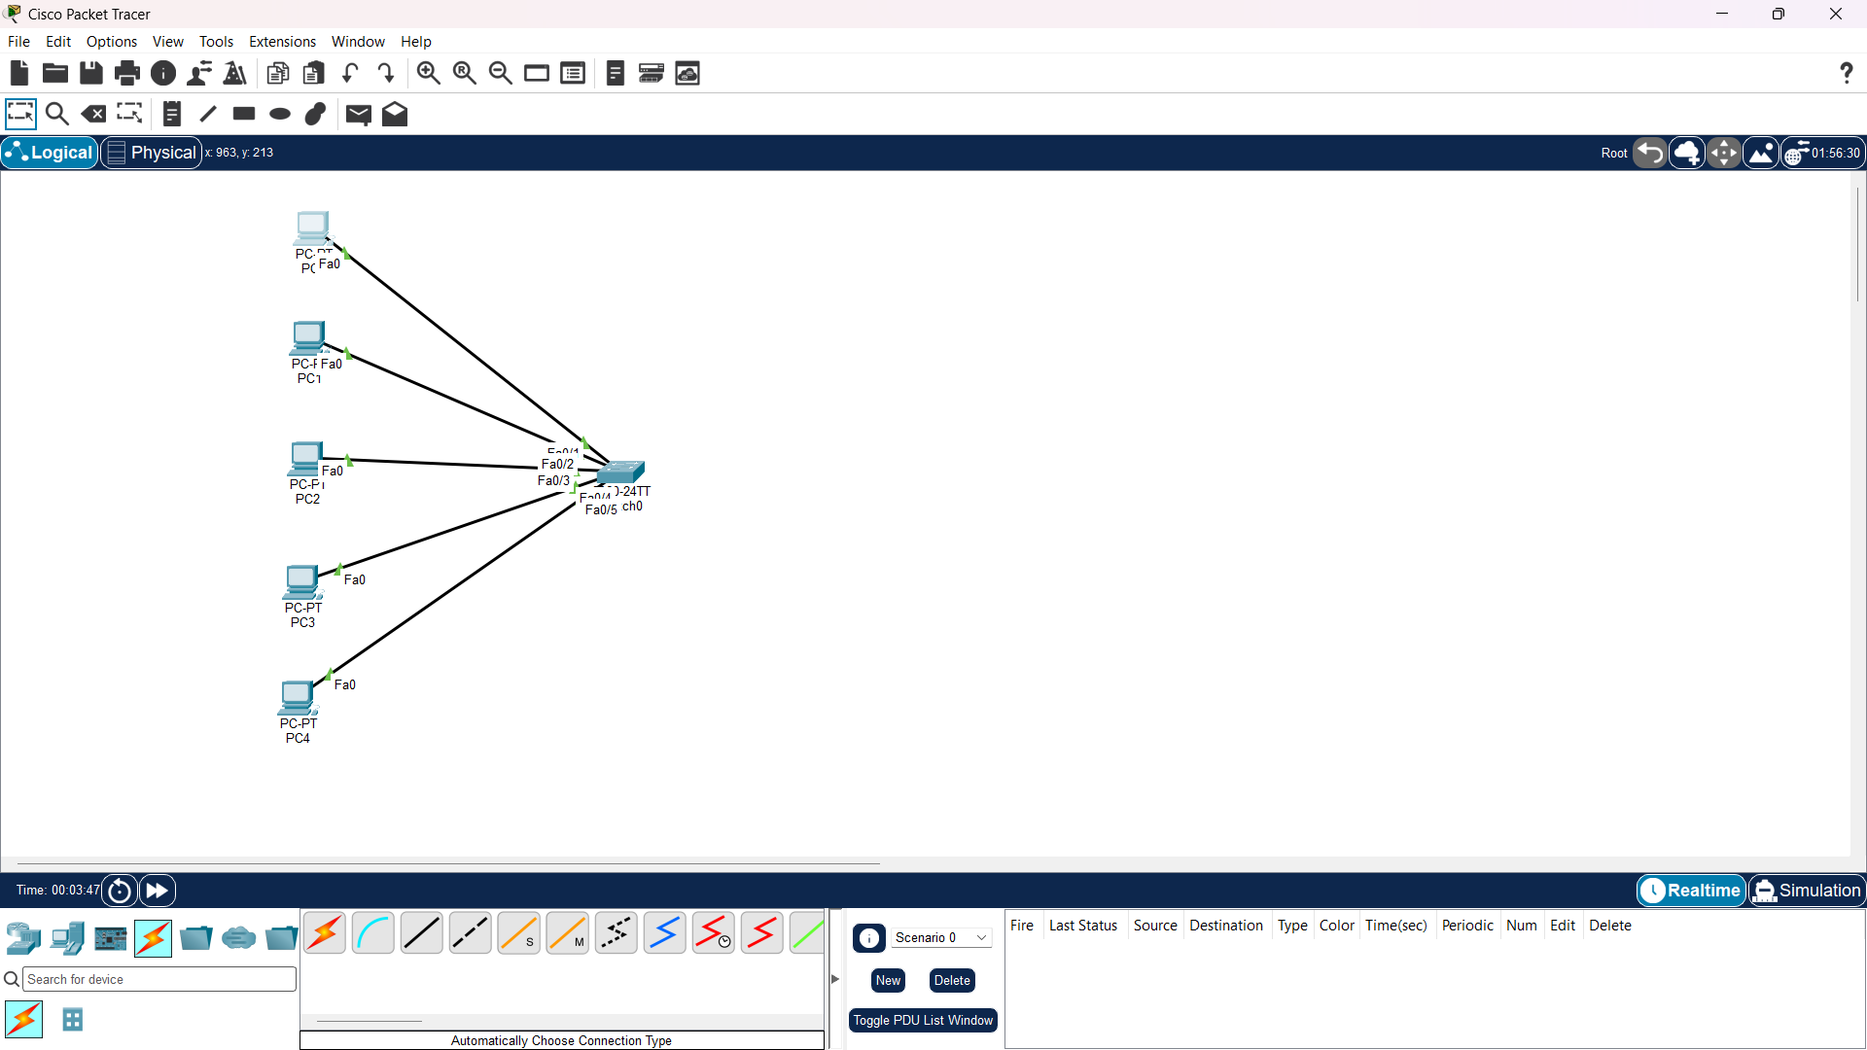
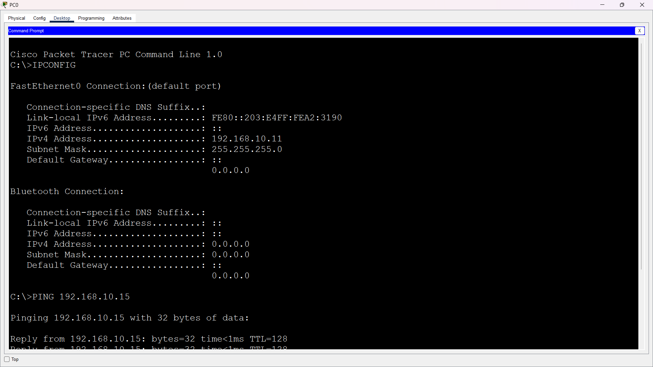
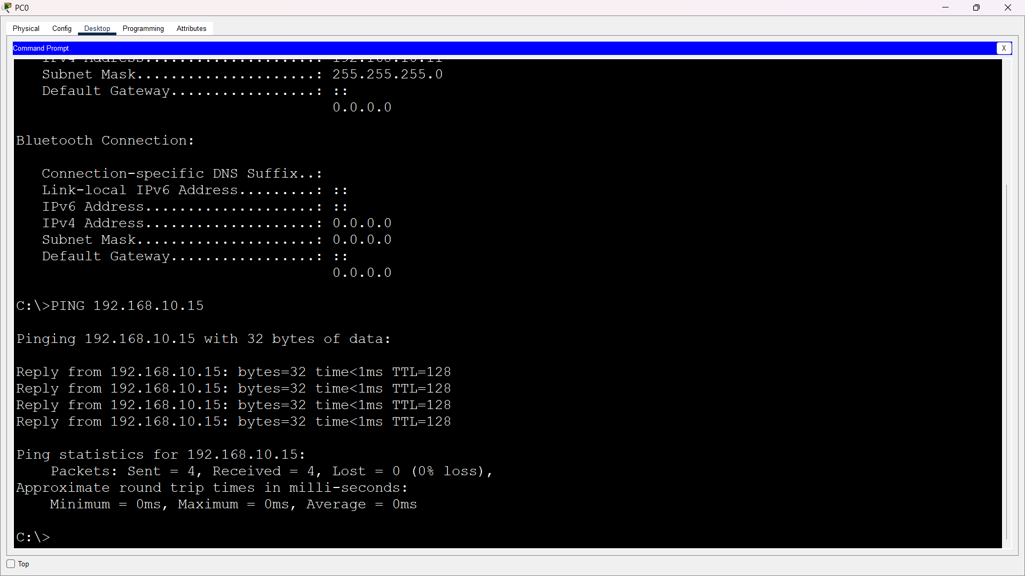
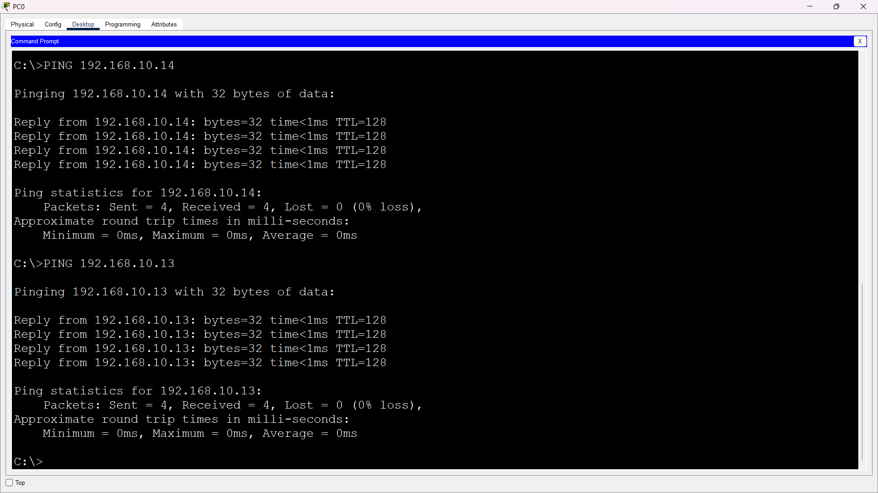
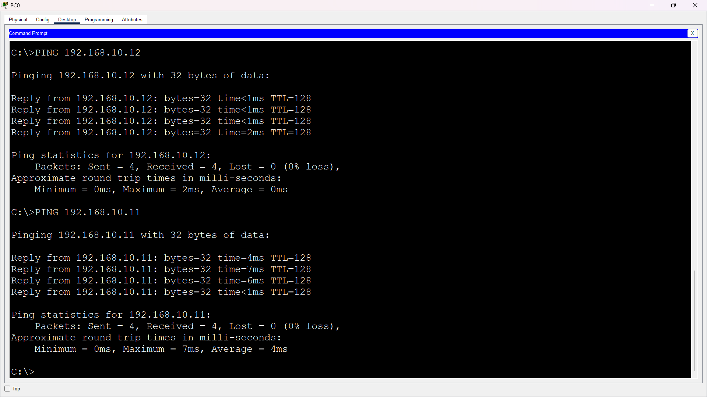
Result: All five devices use unique IP addresses in the same /24 subnet, and successful ping replies confirm local connectivity.

Q2. Configure DHCP for Three Devices
Objective: Configure a DHCP service that automatically provides unique addresses to at least three clients.

Procedure
1. Create a network containing one DHCP server, one switch and at least three client devices.
2. Give the DHCP server a static address such as 192.168.20.2/24.
3. Create a DHCP pool with start address 192.168.20.10, subnet mask 255.255.255.0 and enough addresses for the clients.
4. Enable the DHCP service.
5. On PC0, PC1 and PC2, select DHCP/automatic IP configuration.
6. Verify that each device receives a different address from the configured 192.168.20.0/24 range.
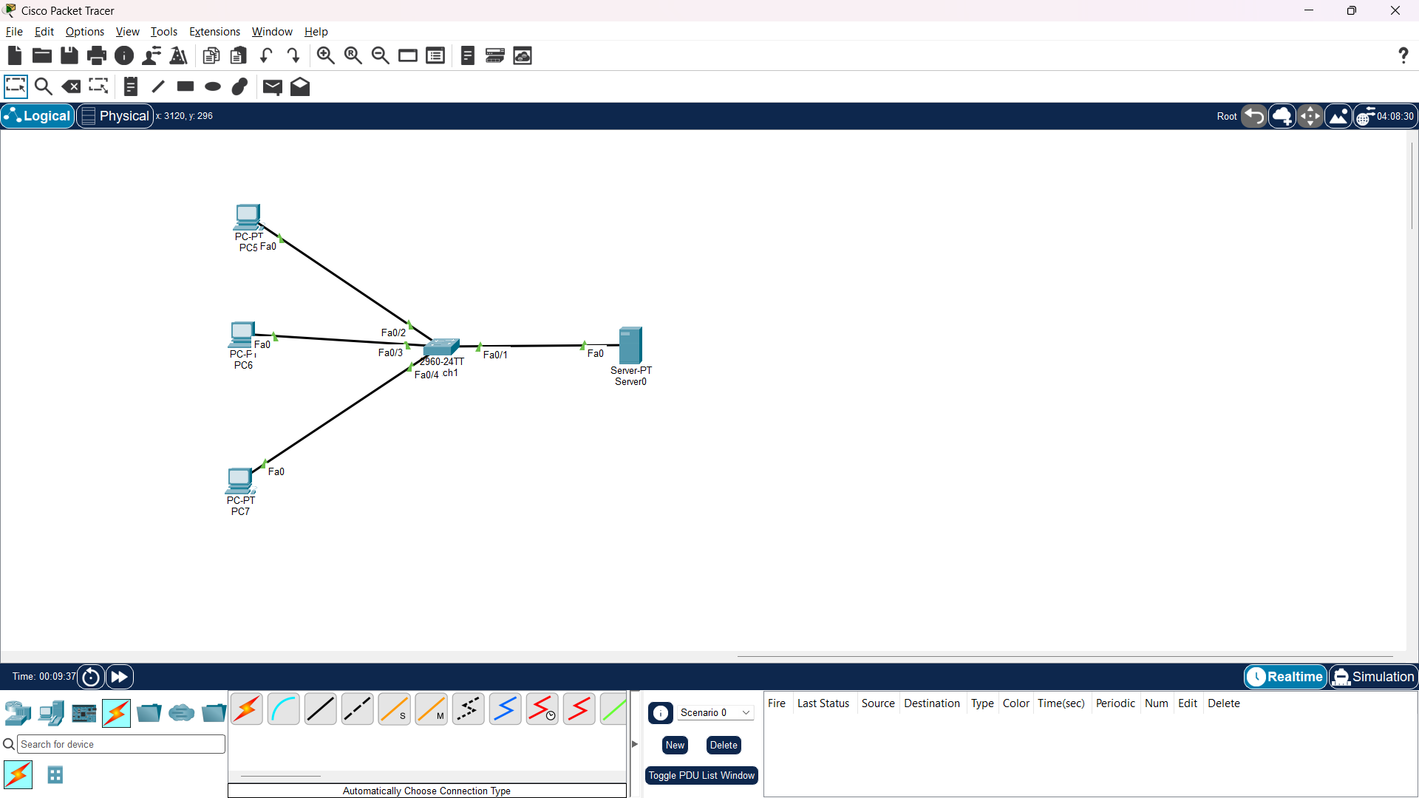
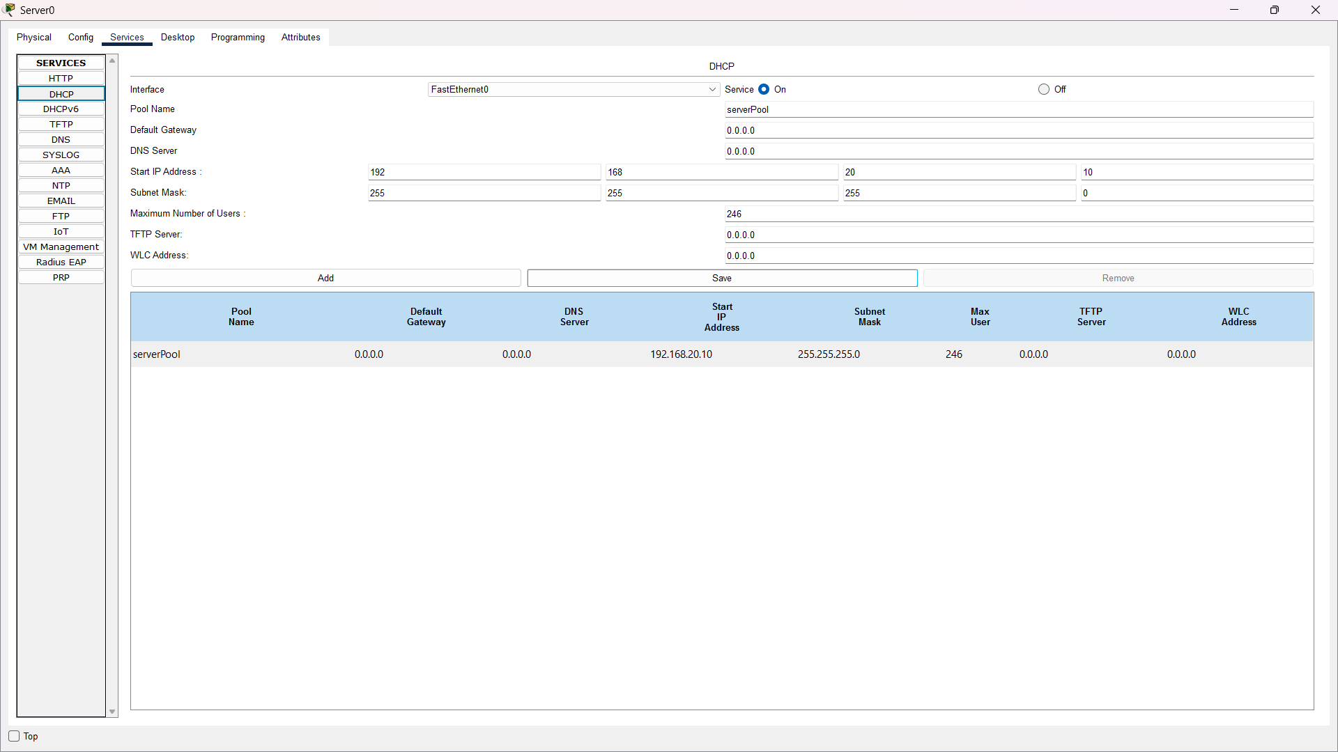
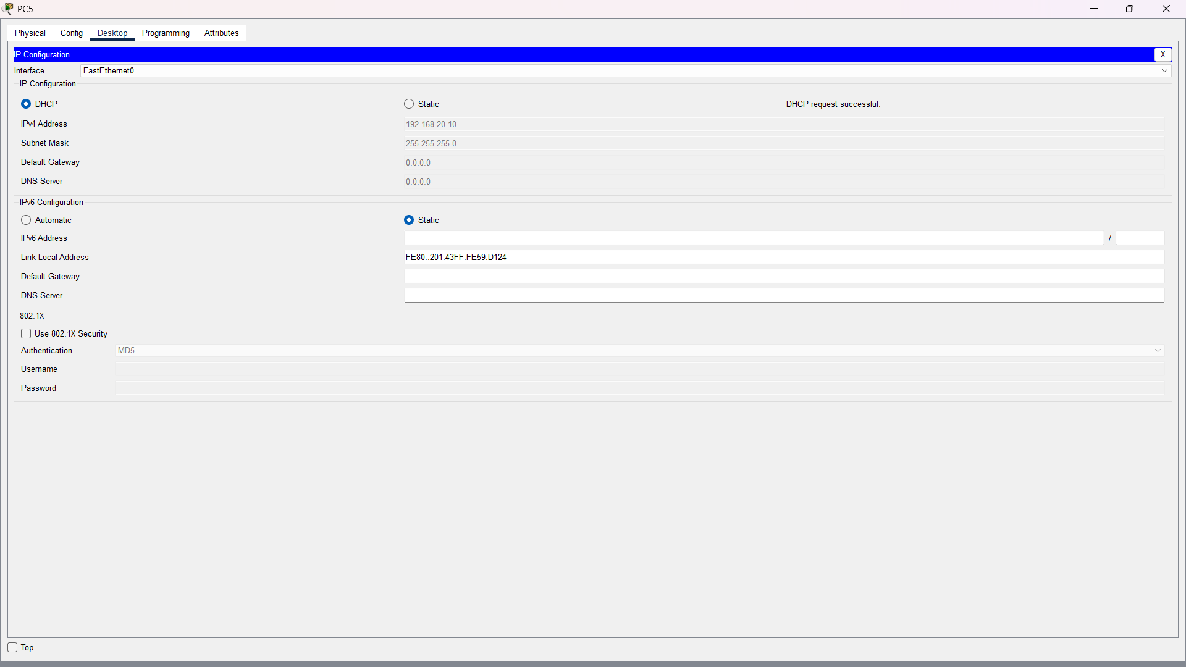
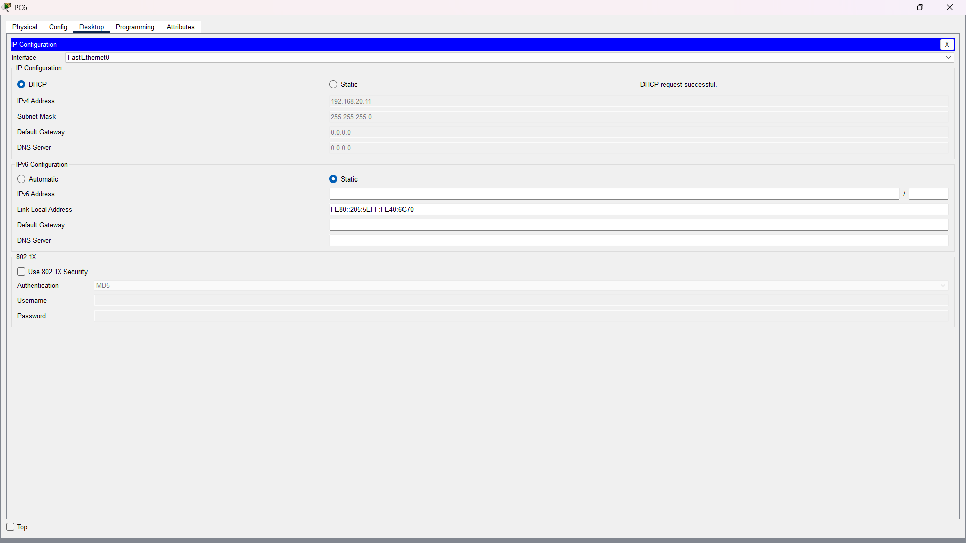
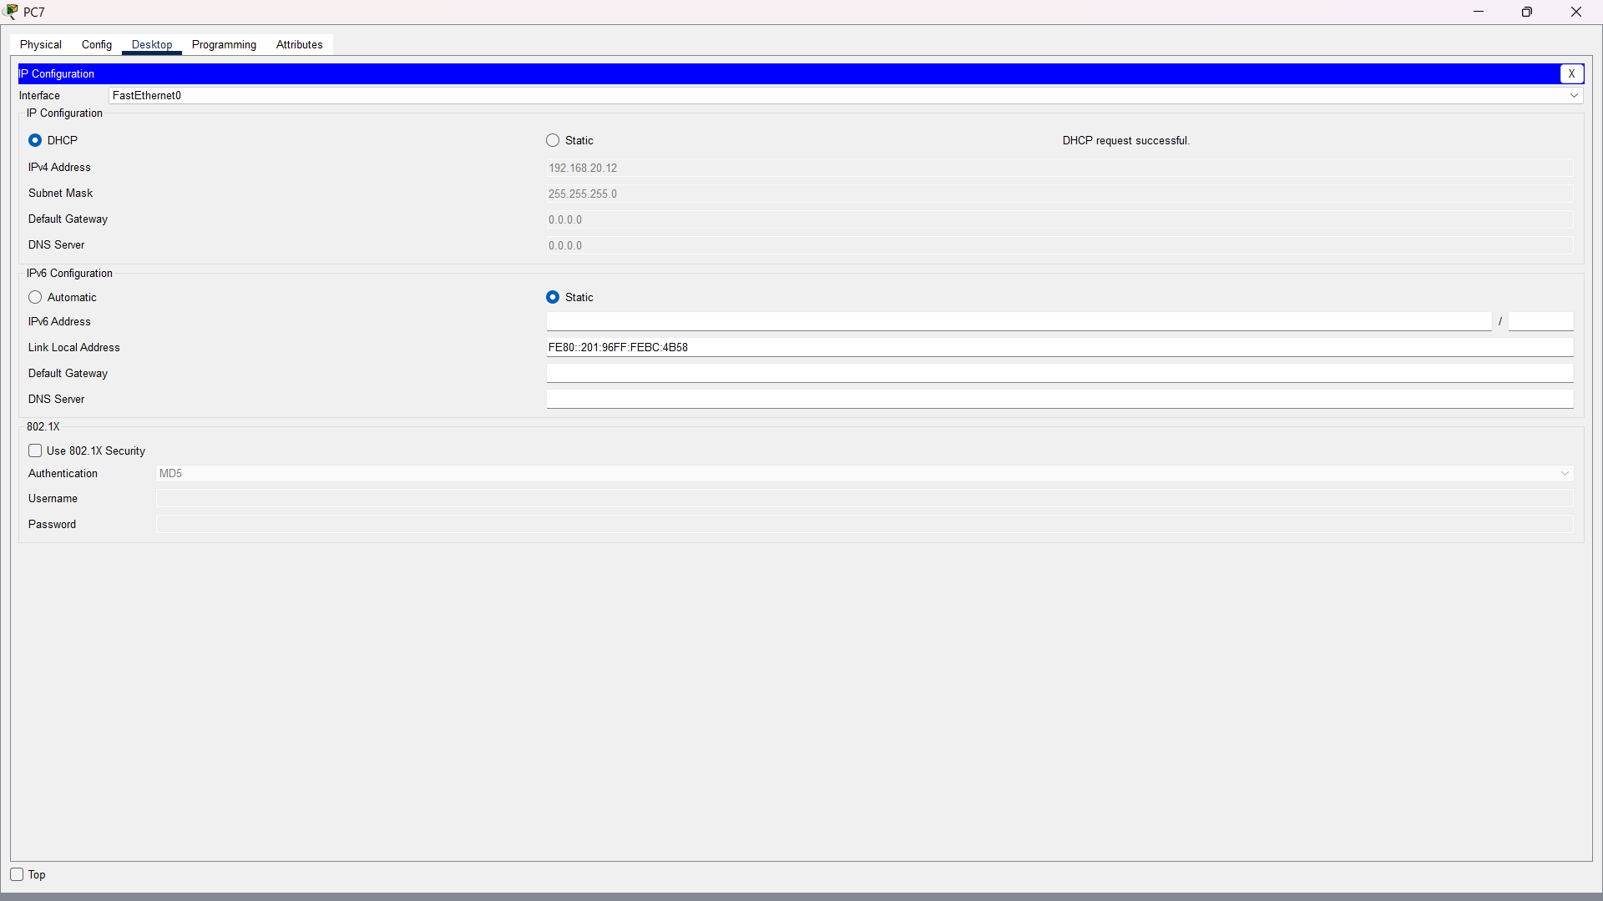

Q3. Configure DNS for musicplayer.local
Objective: Map a custom local hostname to a local web server/device so users can access it by name.

Procedure
1. Use a local server at 192.168.30.50 and a DNS service at 192.168.30.2, or use a hosts-file entry for a quick local test.
2. Create a DNS A record: musicplayer.local → 192.168.30.50.
3. Configure the client to use 192.168.30.2 as its DNS server.
4. Test the name with: ping musicplayer.local or nslookup musicplayer.local.
5. If a web service is running on 192.168.30.50, open a browser and enter musicplayer.local.
6. For a Windows hosts-file test, an entry such as '192.168.30.50 musicplayer.local' can be used instead of a DNS server.
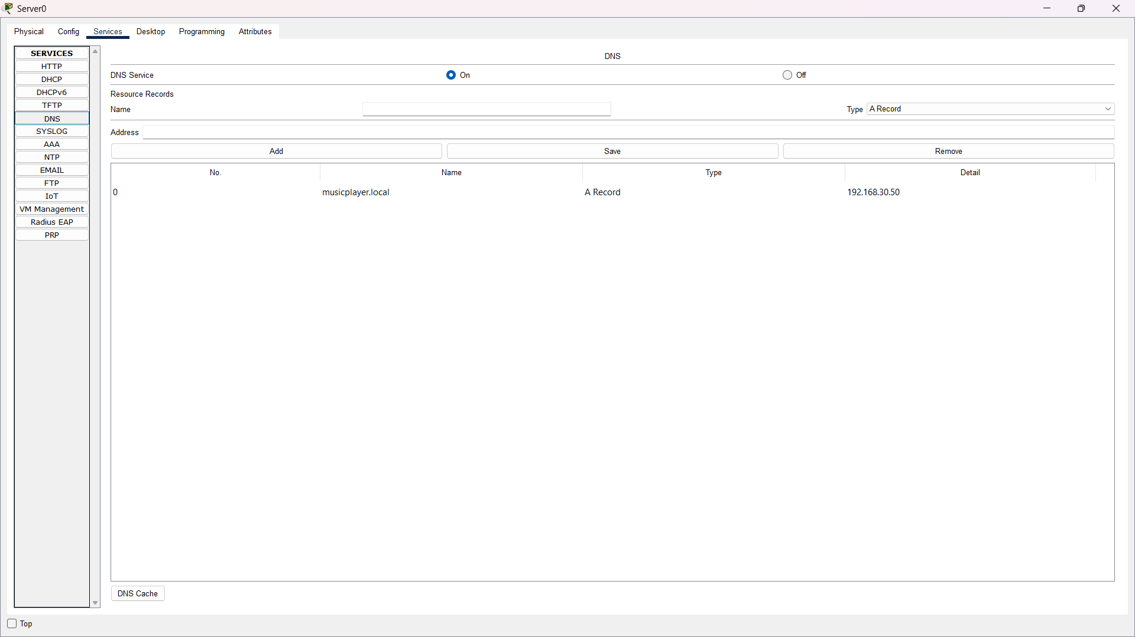
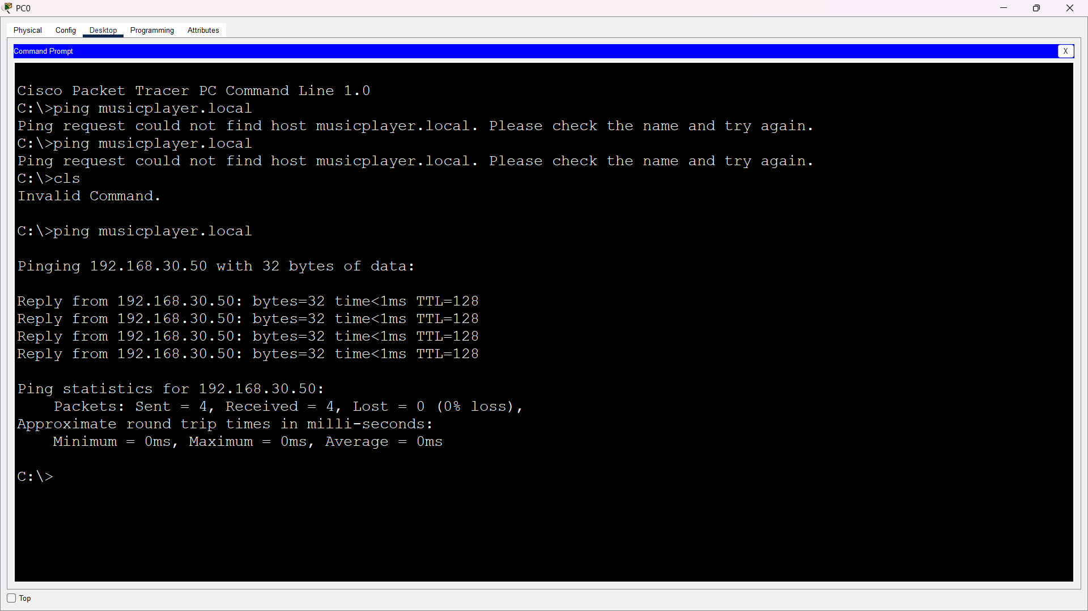
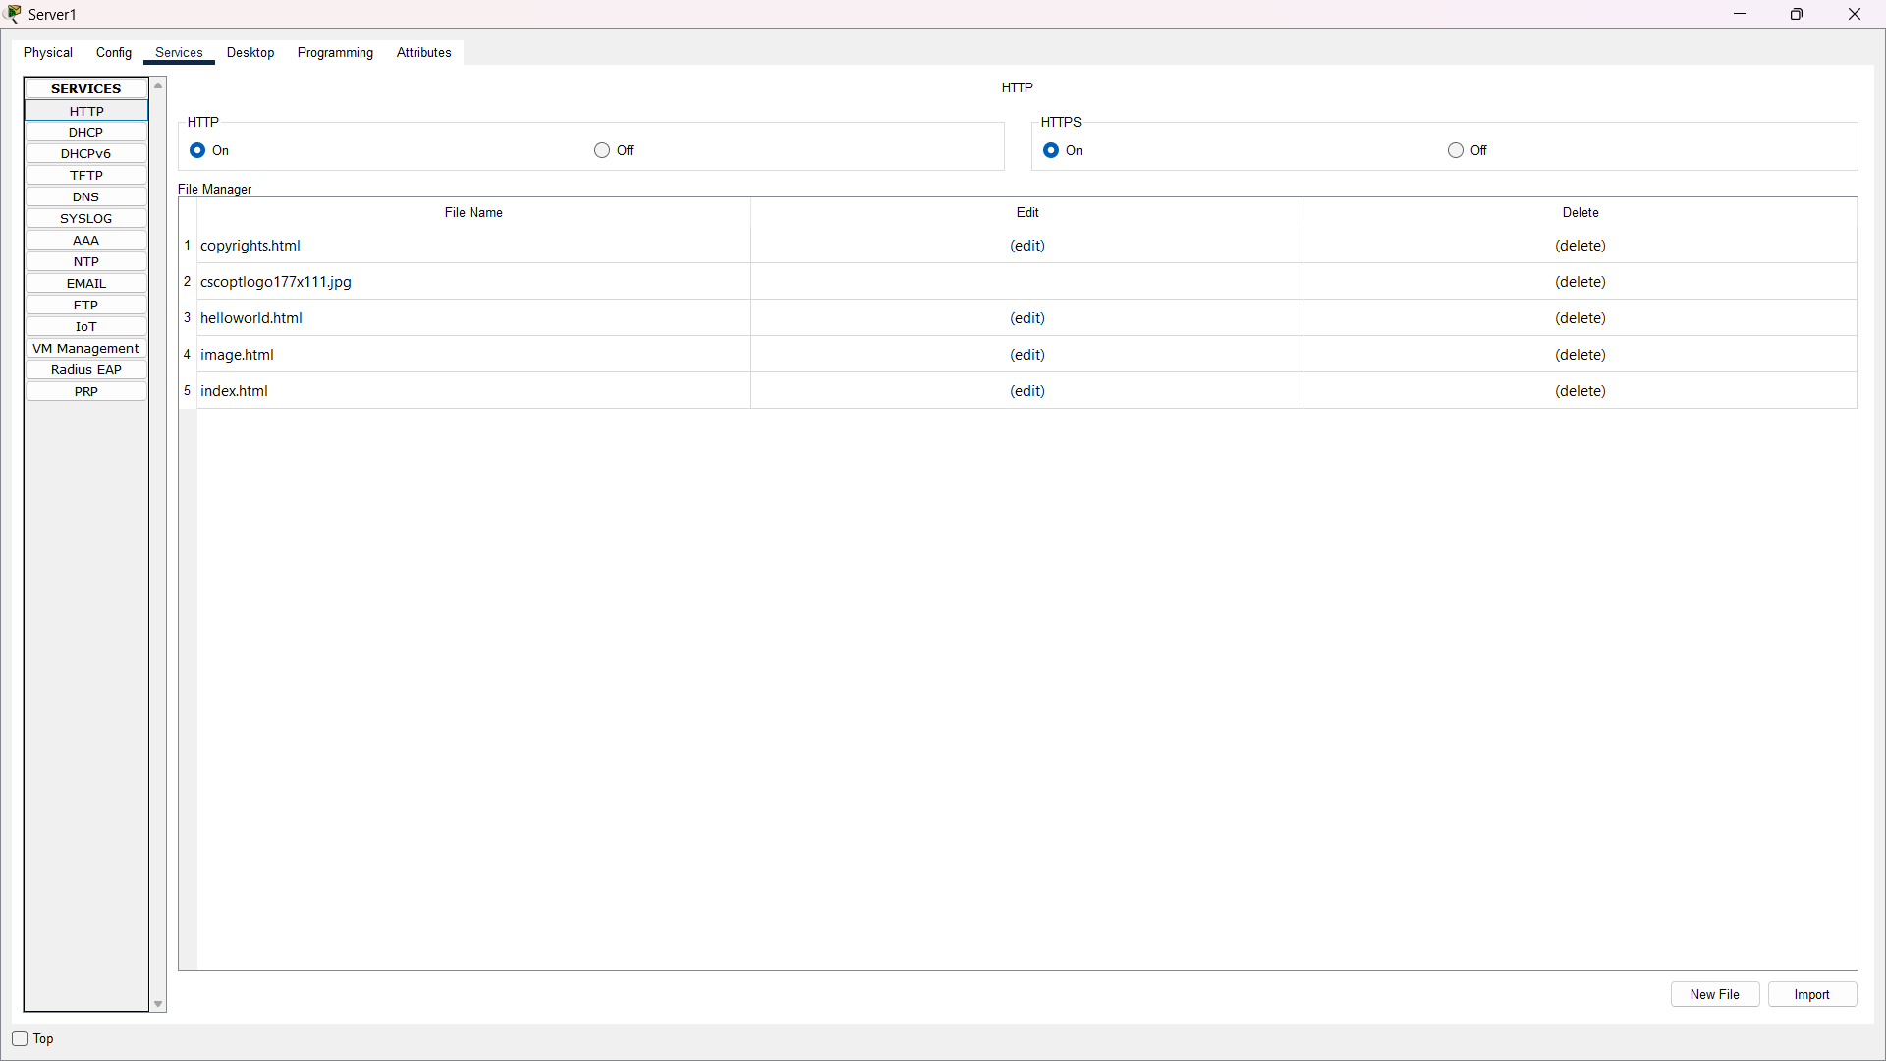
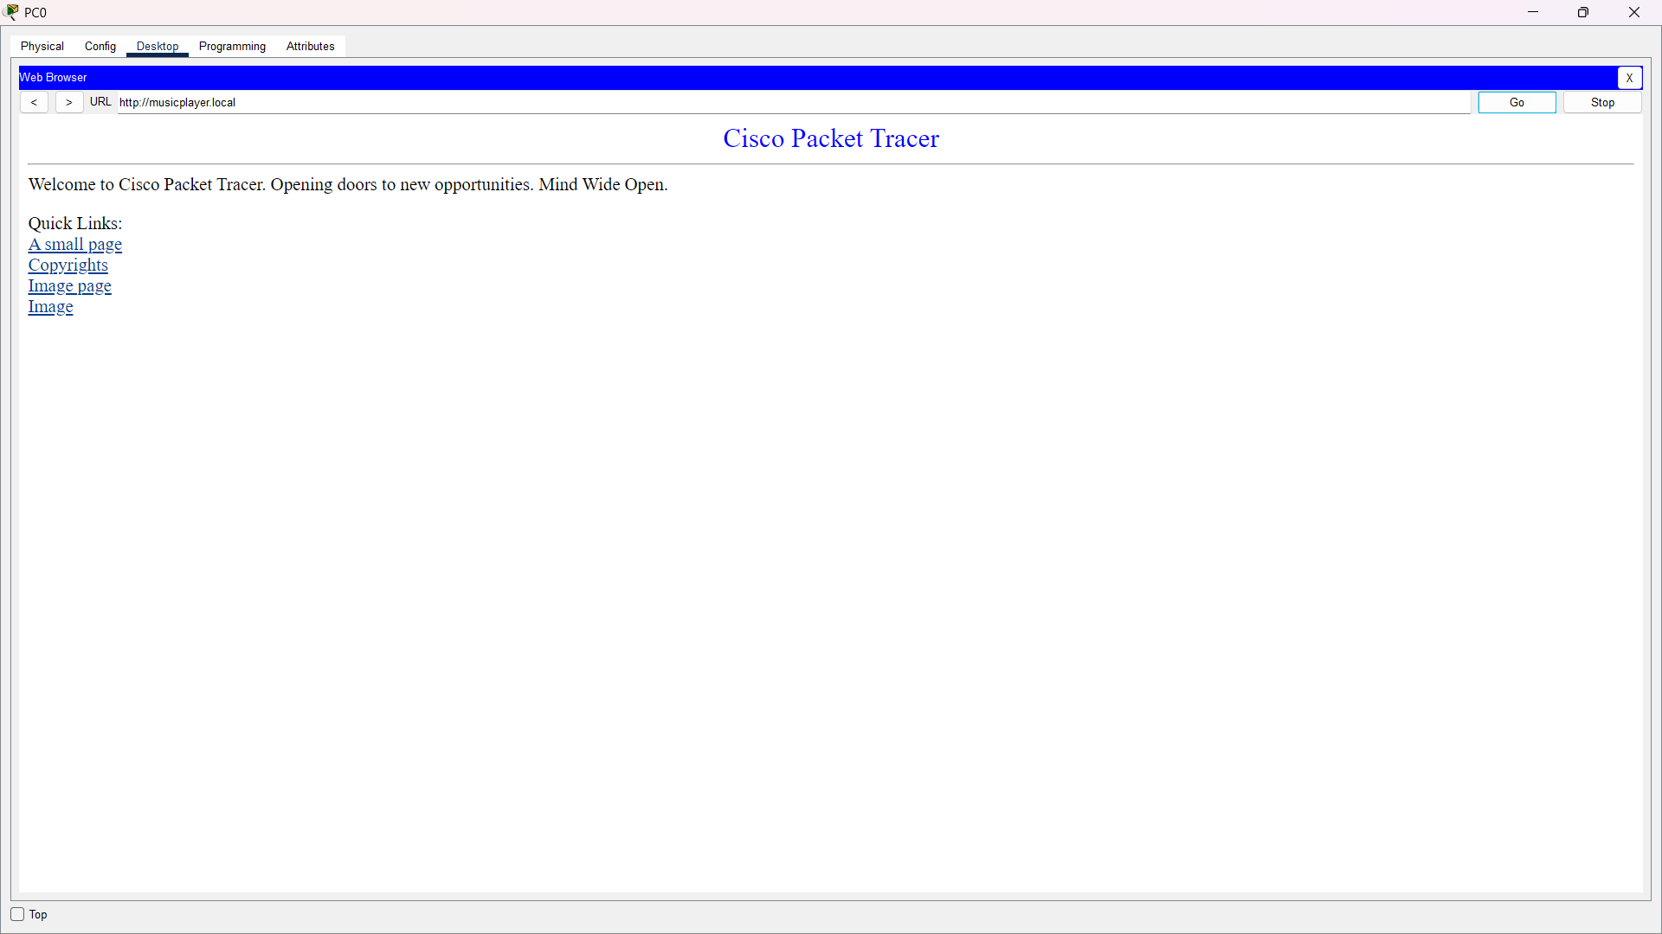

Result: The custom hostname resolves to 192.168.30.50. When a web service is present at that address, the hostname can be used to open the local page.

Q4. Create VLAN 10 and VLAN 20
Objective: Separate four devices into two VLANs and test same-VLAN and cross-VLAN communication.

Procedure
1. Create VLAN 10 and name it Workstations.
2. Create VLAN 20 and name it Smart_Devices.
3. Assign the switch ports connected to PC0 and PC1 as access ports in VLAN 10.
4. Assign the ports connected to PC2 and PC3 as access ports in VLAN 20.
5. Give VLAN 10 devices addresses in one subnet, for example 192.168.10.0/24, and VLAN 20 devices addresses in another, for example 192.168.20.0/24.
6. Ping PC1 from PC0; the same-VLAN communication should work.
7. Ping a VLAN 20 device from a VLAN 10 device. Without inter-VLAN routing, the cross-VLAN communication should fail.
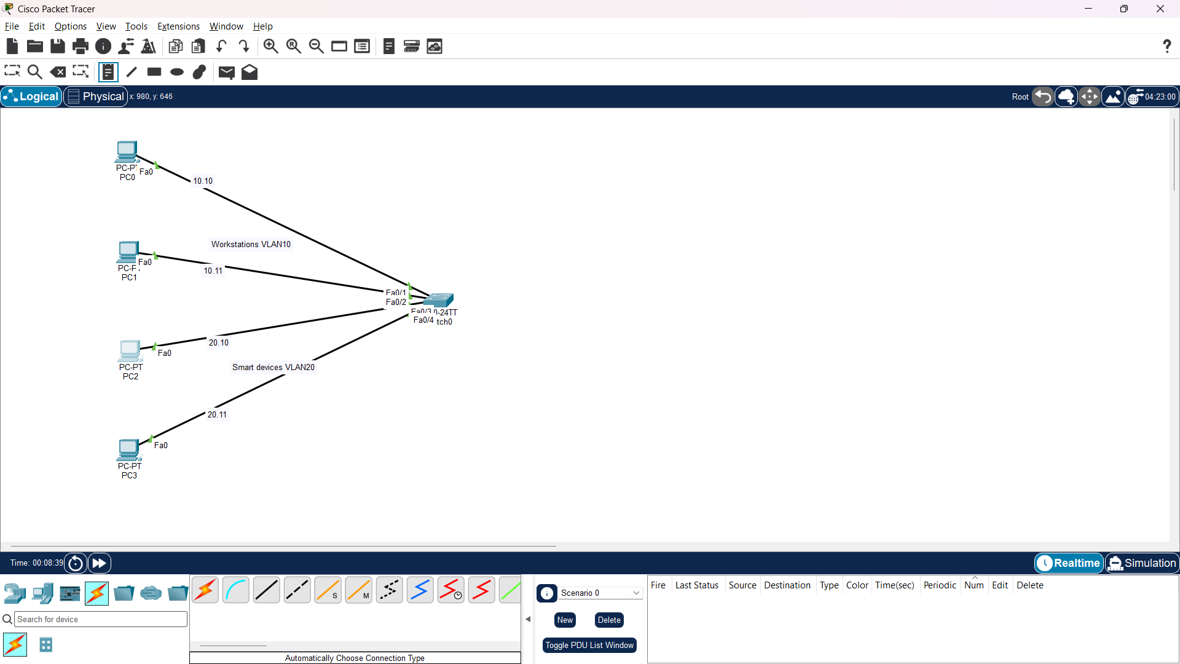
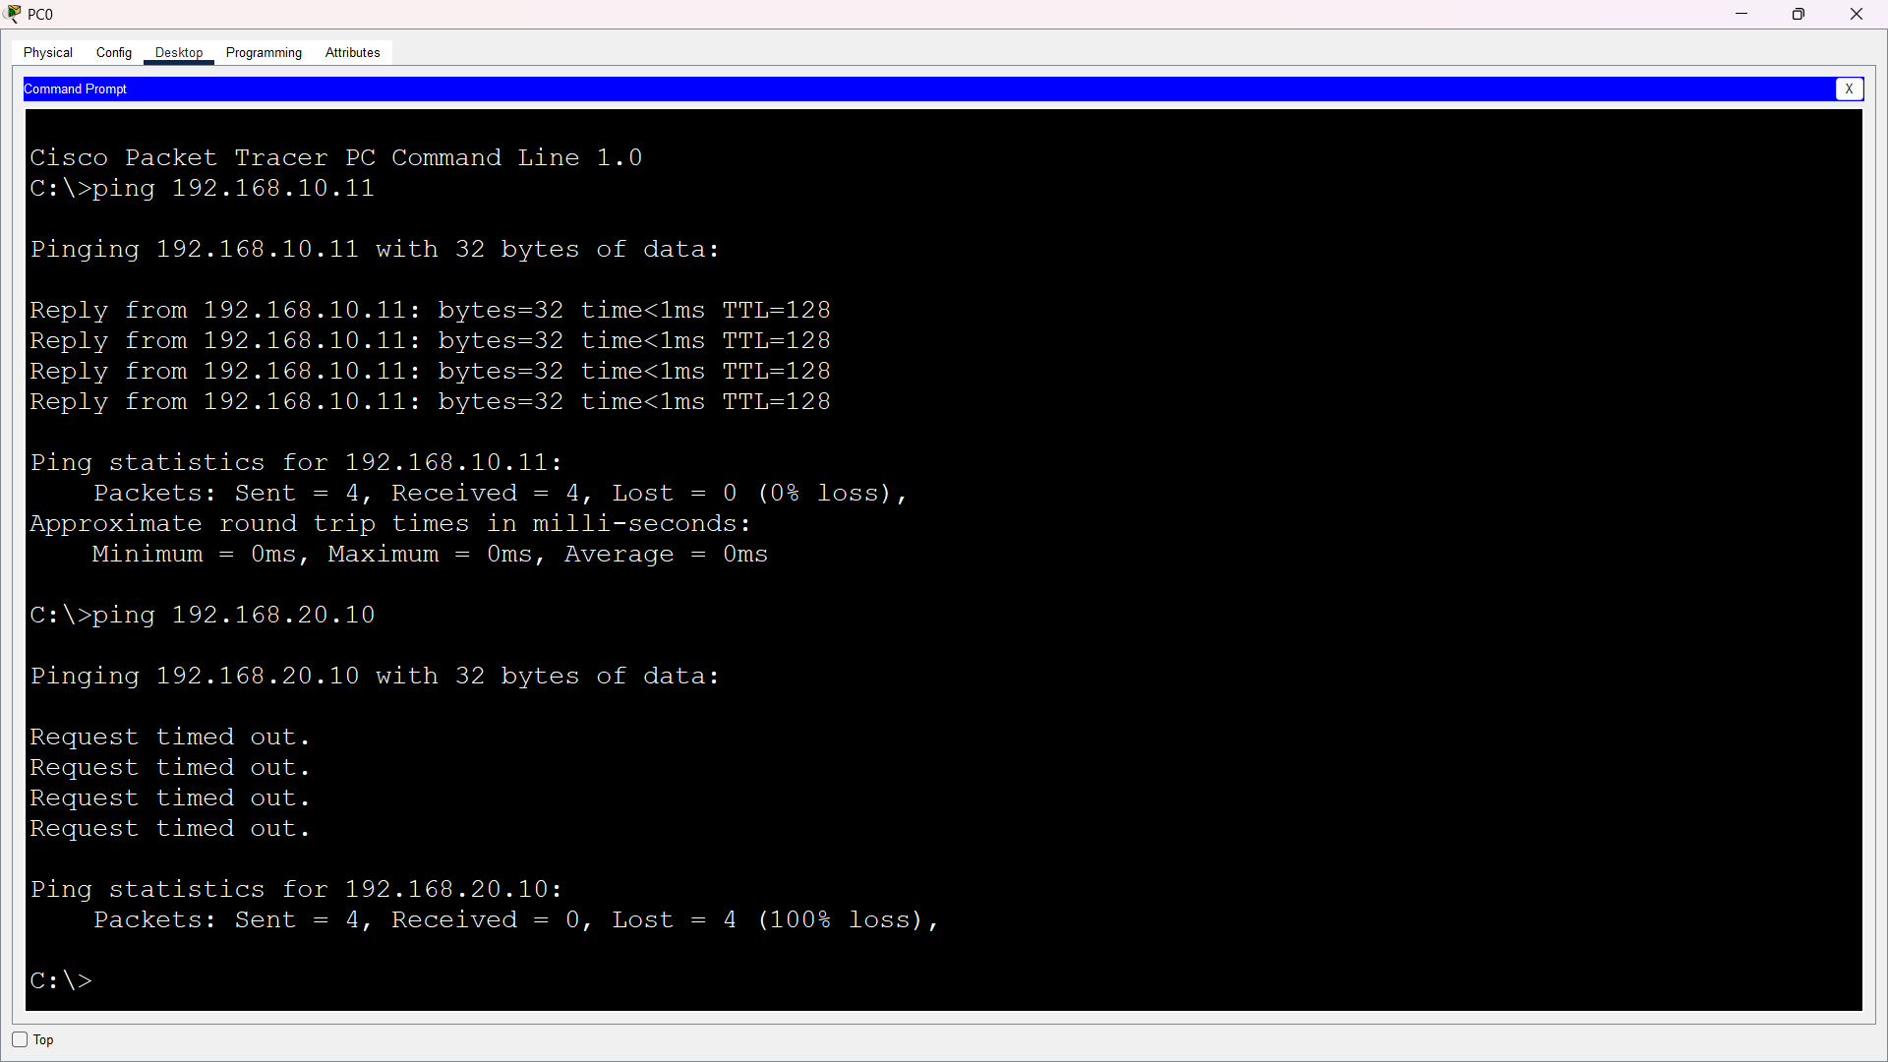

Result: Devices in the same VLAN can communicate through the switch, while devices in different VLANs remain isolated until inter-VLAN routing is configured.

Q5. Configure NAT for Simulated Internet Access
Objective: Configure a router to translate private LAN addresses so internal devices can reach a simulated external server.

Procedure
1. Create a LAN with clients, a switch and a router. Connect the router to an external network/server.
2. Use an inside LAN such as 192.168.40.0/24 and configure the router's LAN interface as 192.168.40.1.
3. Configure an outside router interface on a different network, for example 203.0.113.0/24 in the simulation.
4. Mark the LAN-facing router interface as NAT inside and the external-facing interface as NAT outside.
5. Create an ACL matching the private LAN and configure NAT overload/PAT using the outside interface.
6. Set each LAN client's default gateway to 192.168.40.1.
7. Ping or access the simulated external server and verify that traffic crosses the router.

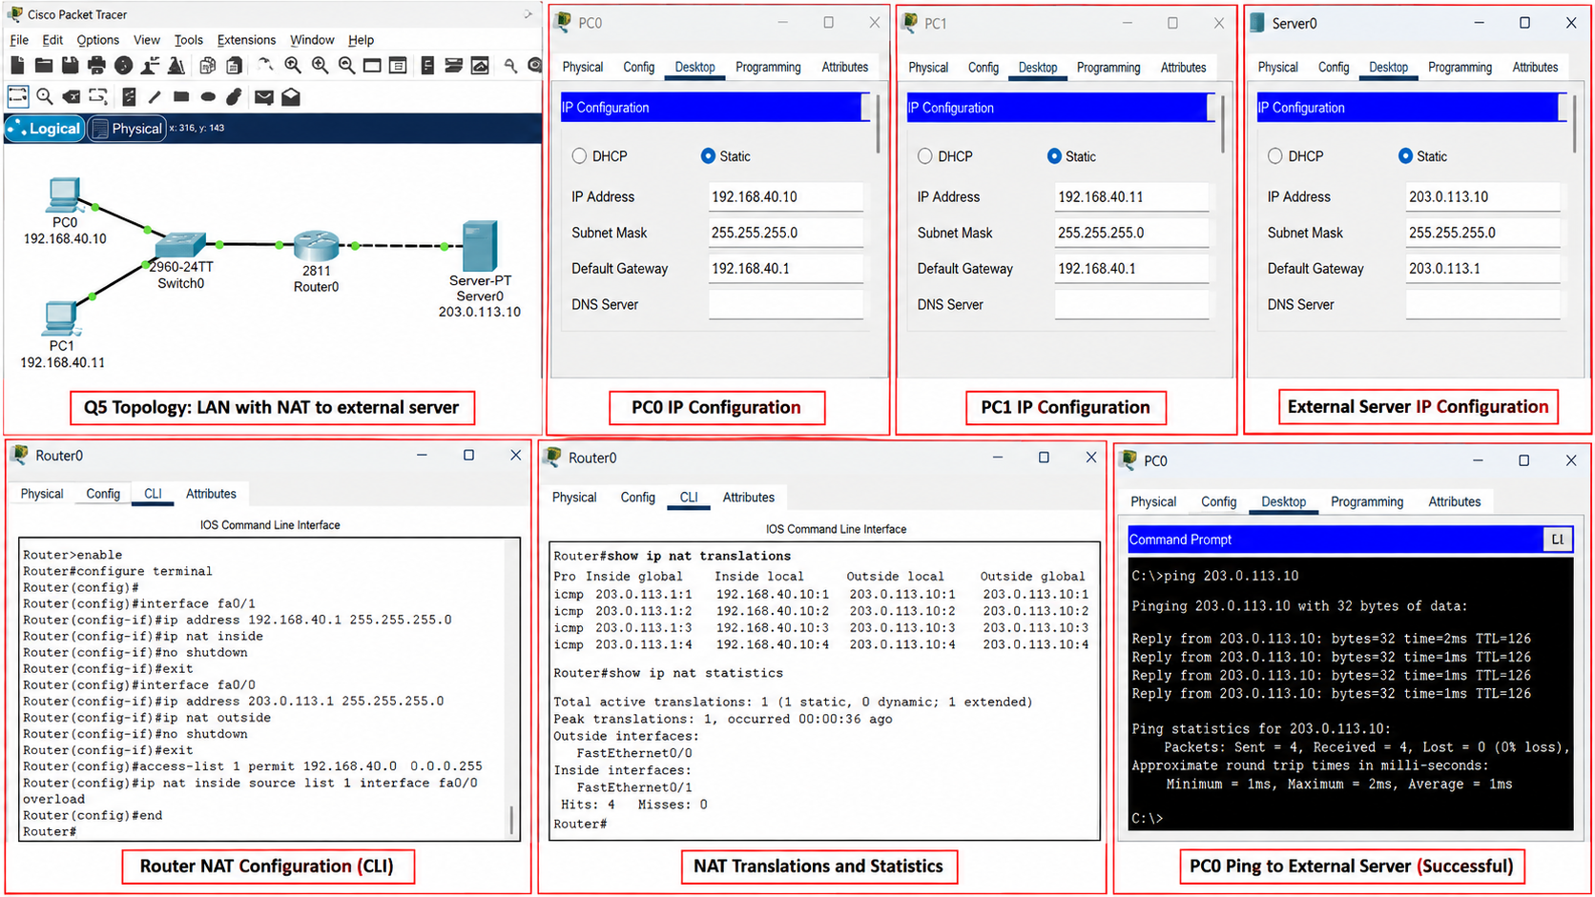
Result: Private LAN devices can reach the simulated external network through the NAT router.

Conclusion
This practical demonstrates five important networking concepts: static IPv4 addressing, automatic addressing with DHCP, hostname resolution with DNS, logical network separation using VLANs, and private-to-external connectivity using NAT.

